Testing Evaluation

Theme Survey Results

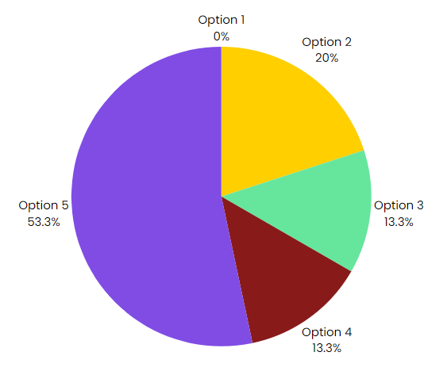

Prototype Survey Results

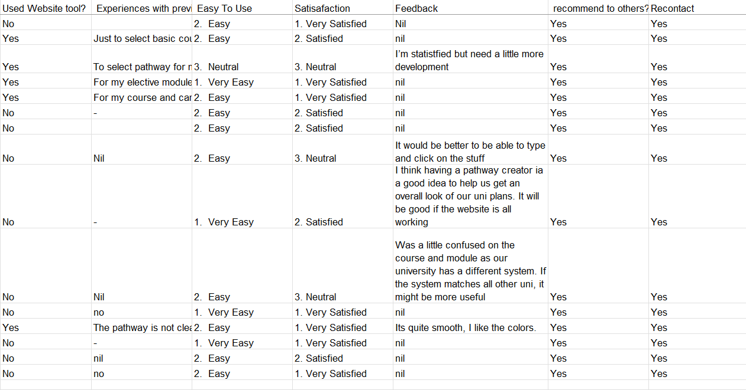

Most of the survey feedback and data collection were from prototype restrictions which caused many confusions.

Considered Feedback

After looking through the data collected and survey results, one of the user’s data collected was considered.

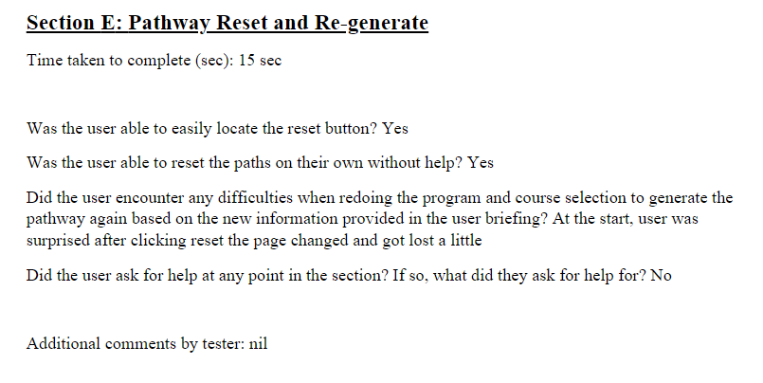

One of our testee encountered an issue where clicking on the reset button immediately refreshed the page into the starting page.

Changes to be made

One key point to be taken from the testing is creating prompts to confirm with the user on their actions. An example would be when the user selects “Reset”, a prompt to confirm reset will appear before bringing user to the starting page to re-generate their pathway. That way, we can minimise mistakes and confusion.